# Portal

Portal can be accessed even if you’re not connected (anonymous user). But if you want to used an API, a user account is required to subscribe to plans.

Default view in portal shows all the API accessible to the authenticated user (or only public API for anonymous user).

What are the rules for API accessibility:

* Public API
* Private API: if user is a member of the API (user, owner, primary_owner)

**Login**

1) Click Login.

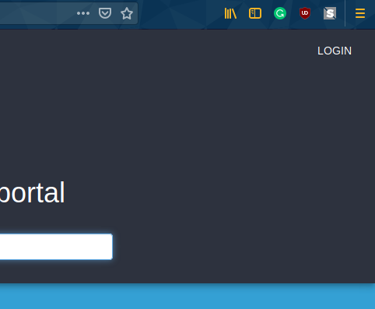

2) Click Sign In with Google.

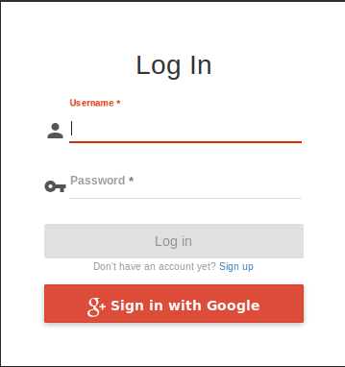

3) Insert **Student Gmail.** Click Next.

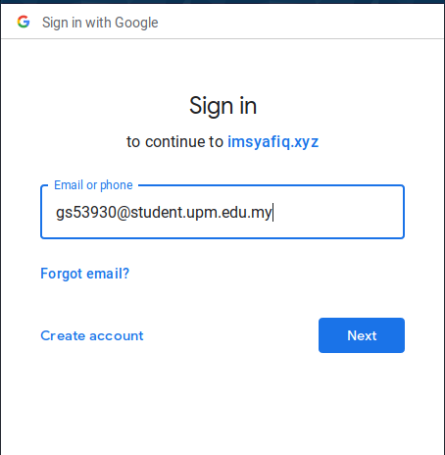

4) Insert student **UPM-ID** and **Password.** Click Login.

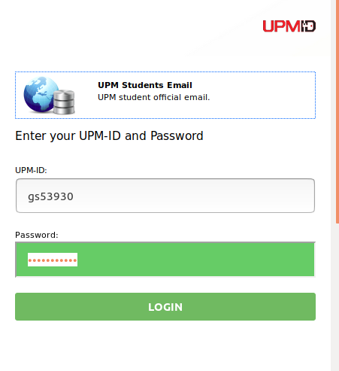

**Subscribe to an API**

API Gateway platform exposes an API gallery also known as API catalog to let developers application to browse APIs, request access and generate subscriptions to secure access and identify consumers for monitoring and analytics.

To access theses APIs consumers, must subscribe to the [APIs' plans](https://docs.gravitee.io/apim_publisherguide_plans_subscriptions.html) with their registered application to start playing with the APIs.

**Create an Application**

1) Login to portal.

2) Open the user menu (top right) . Click Applications.

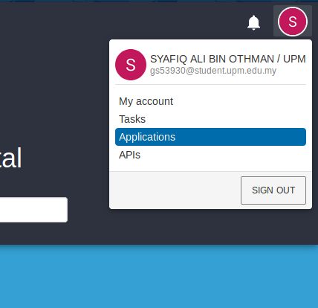

3)